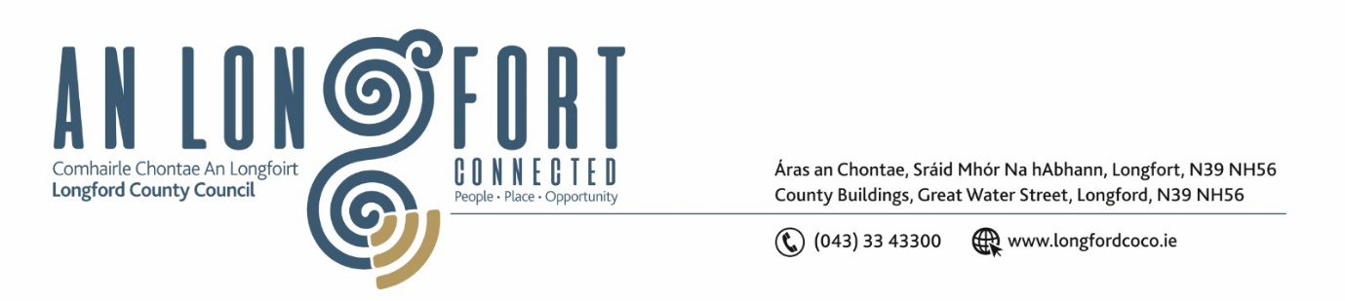

**Minutes of Meeting of Longford County Council**

**held via Microsoft Teams on**

**Wednesday, 8 June 2022 at 3pm**

____________________________________________________________________

**PRESIDING**: Councillor Peggy Nolan, Cathaoirleach

**MEMBERS PRESENT**: Councillors –John Browne, Seamus Butler, Mick Cahill, Colin Dalton, PJ Reilly, Gerard Hagan, Martin Monaghan, Paul Ross, Pat O’Toole, Colm Murray, Garry Murtagh, Turlough Mc Govern, Gerard Farrell, Uruemu Adejinmi and Paraic Brady

**IN ATTENDANCE:**  Mr. Paddy Mahon, Chief Executive

Ms. Barbara Heslin, Director of Services

Mr. John Brannigan, Director of Services

Ms. Samantha Healy, Director of Services

Ms. Fema Farrell, A/ Head of Finance/Director of Services

**APOLOGIES:** Mr. John McKeon, Head of Finance/Director of Services

Councillors Gerry Warnock and Mark Casey

**MEETINGS**

**ADMINISTRATOR**: Ann Marie Mc Keon

**ADOPTION OF MINUTES**

On the proposal of Councillor John Browne seconded by Councillor Colm Murray the Minutes of Monthly Meeting of Longford County Council held on the 11 May 2022, as circulated, were confirmed and adopted.

**MATTERS ARISING FROM MINUTES**

None.

**DECLARATION OF INTEREST BY MEMBERS**

None.

**CHIEF EXECUTIVE REPORT**

Noted.

**MINUTES OF CORPORATE POLICY GROUP MEETING HELD ON THE 11 APRIL 2022 - CIRCULATED**

The adopted Minutes of Corporate Policy Group Meeting held on the 11 April 2022, as circulated, were noted.

**PLANNING AND PROJECT DELIVERY**

**Planning Applications**

The list of Planning Applications received since last meeting of the Council were noted.

**Consideration of Part VIII No. 90 - Lisryan Community Walkway - Construction of a**

**community walk to include upgrade of laneway, provision of new path, new bridge,**

**fencing and ancillary works in the village of Lisryan. Report in Accordance with**

**Section 179 of the Planning and Development Act 2000 (as amended) and Part 8 of the**

**Planning & Development Regulations 2001 (As Amended) June 2021 – as circulated**

On the proposal of Councillor Turlough Mc Govern, seconded by Councillor Garry Murtagh

the members unanimously adopted the Part 8 Number ninety – Lisryan Community

Walkway as circulated.

**COMMUNITY, CORPORATE AND ENTERPRISE**

**Consideration and adoption of Draft Annual Report 2021 prepared in accordance with Section 221 of Local Government Act 2001 as amended – as circulated**

On the proposal of Councillor Mick Cahill, seconded by Councillor Colm Murray the members unanimously agreed to adopt the Annual Report 2021 as circulated.

Director of Services, Barbara Heslin acknowledged the work of all the team involved in the collation of the required information and the editing and presentation of the Annual Report.

**INFRASTRUCTURE, HOUSING AND INNOVATION**

**The following Notice of Motion was proposed by Councillor Pat O’Toole and seconded by Councillor Seamus Butler -**

“I call on the Minister for Housing, Local Government and Heritage to remove the population cap on the Affordable Homes aspect of the Housing for All Rebuilding Ireland Plan to allow towns like Edgeworthstown, Ballymahon and Granard to be included in the Scheme.”

**Response**

The members unanimously agreed to write to Minister for Housing, Local Government and Heritage outlining the concerns of the Council.

**The following Notice of Motion was proposed by Councillor Paul Ross and seconded by Councillor Mick Cahill -**

That Longford County Council prepare a tender for contractors to apply to refurbish our reletting housing stock to try and deal with the huge backlog in getting our council houses refurbished and reoccupied by new tenants.

**Response**

Longford County Council Maintenance Framework was renewed in Q3 2021. It was advertised on etenders seeking Expressions of Interest nationally to carry out maintenance and pre-let works for Longford County Council. Fewer satisfactory tenderers than expected were received. Currently all the contractors on the maintenance framework are at full capacity in the delivery and turnaround of houses and pre-lets. Nationally, there appears to be a limited number of contractors willing to carry out this work and other local authorities have experienced similar issues.  The indications are that larger contractors are focused on carrying out bigger capital projects and new-build construction where the financial returns are higher.  Consideration will be given to advertising Expressions of Interest again later this year.

**GENERAL**

**The following Notice of Motion was proposed by Councillor Paul Ross and seconded by Councillor PJ Reilly -**

That Longford County Council calls on the Minister for Health to move the Tobacco and Nicotine inhaling products bill into law as soon as possible in order to regulate the sale of vaping products in Ireland.

The members unanimously agreed to write to Minister for Health.

**CORRESPONDENCE**

Letter dated 9 May 2022 from Office of the Tánaiste – Re Turf Cutting – as circulated – was noted.

**TRAINING**

Report from the Corporate Policy Group on training was noted.

**SYMPATHY**

Councillor Colm Murray proposed, and Councillor Seamus Butler seconded that a vote of sympathy be extended to Peter Burke and family, Mullingar on the death of Peter Burke Senior, to Anne Lee and family on the death of Anne’s sister Miriam Kirwan, to the Halion family, Dublin and Tuam on the death of Anne Halion (former Local Government Auditor with Longford County Council) and to the Dalton and Renihan family on the death of Patricia Renihan.

Best Wishes

Councillor Paul Ross and the elected members wished Jessica Thompson, journalist good wishes in her new role.

This concluded the business of the meeting.

**Ann Marie Mc Keon**

**Signed: _______________________**

**Ann Marie Mc Keon**

**Meetings Administrator.**

**Confirmed and adopted at Meeting of Longford County Council held on the 13 July 2022.**

**Turlough Mc Govern**

**Signed: _______________**

**Cathaoirleach.**

